# Module 4

**Unsupervised Learning and Generative Models in Keras**

**Generative Adversarial Networks (GANs) and TensorFlow**

## 📌 Generative Adversarial Networks (GANs)

Generative Adversarial Networks (GANs) are a class of neural network architectures designed to generate synthetic data that closely resembles real-world data.

They have become widely known for their ability to create realistic content such as images, music, and text.

### 🔹 Concept and Architecture

A GAN consists of two primary components:

* **Generator**: Receives a random noise vector as input and generates synthetic data (e.g., images). Its objective is to produce data that mimics real data as closely as possible.
* **Discriminator**: Receives both real data and synthetic data generated by the generator. It attempts to classify each input as real or fake. Its objective is to accurately distinguish between genuine and generated data samples.

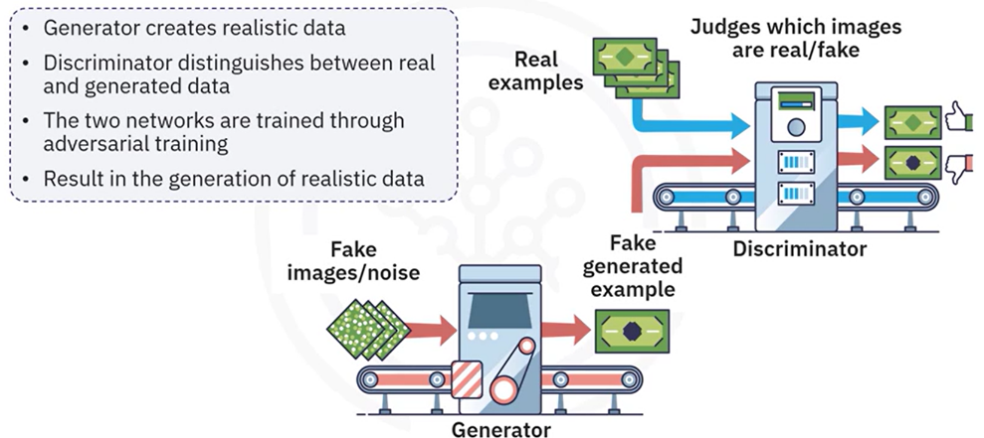

These two networks are trained simultaneously in an adversarial process where:

1. The **generator** is trained to fool the discriminator by creating realistic data.
2. The **discriminator** is trained to correctly identify real versus fake data.

This competition continues over multiple training cycles, pushing both networks to improve. Over time, the generator becomes so proficient that the discriminator can no longer reliably tell the difference between real and generated data.

**🔧** **Dimensionality Reduction:**

Dimensionality reduction techniques reduce the number of variables in a dataset while preserving its essential structure.

Helps simplify data and remove redundancy.

Examples:

* + Principal Component Analysis (PCA)
  + T-distributed Stochastic Neighbor Embedding (t-SNE)

### 🔹 Autoencoders

Autoencoders are neural networks designed for **learning efficient data representations**, often used for dimensionality reduction and feature learning.

The autoencoder is trained to **minimize the difference** between the input and reconstructed output, forcing the network to learn meaningful representations of the data.

**Key Components:**

* **Encoder**: Compresses input data into a lower-dimensional **latent space**.
* **Decoder**: Reconstructs the original input from the latent representation.

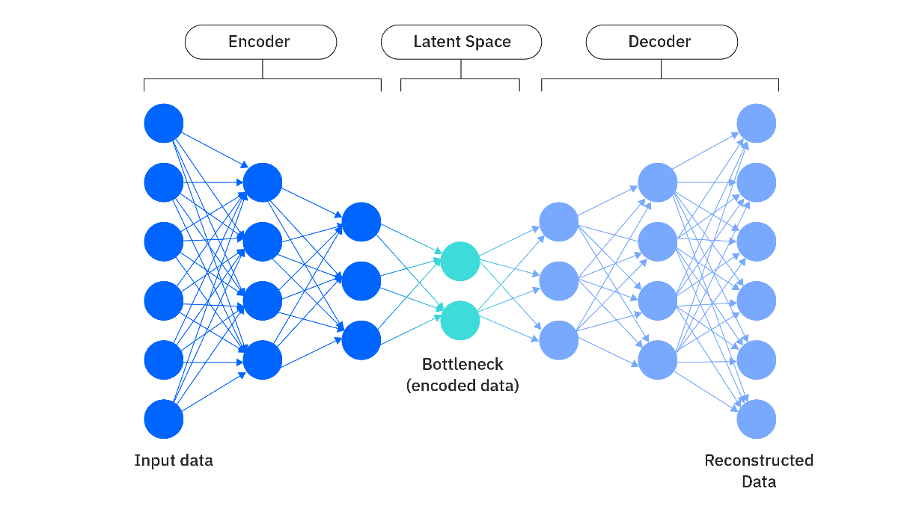

**Simple implementation of an autoencoder in Keras:**

In this code, an autoencoder for a data set with 784 features is defined.

The encoder compresses the input into 64 features, and the decoder reconstructs the original 784 features.

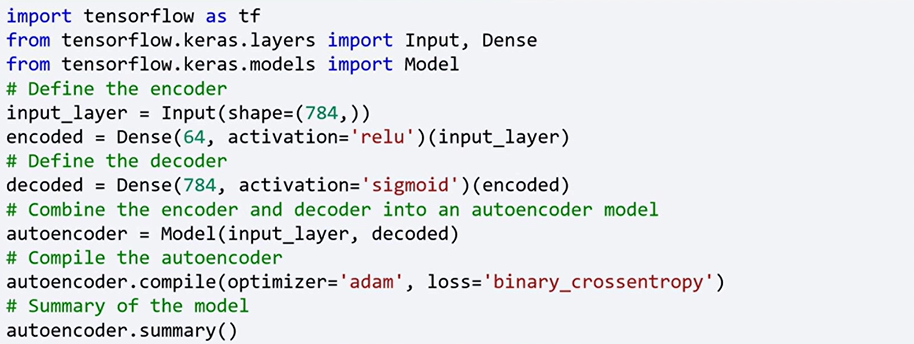

To train the autoencoder, you use the same data for both input and output.

For example, you can use the Modified National Institute of Standards and Technology, MNIST data set as shown in this code.

This code trains the autoencoder to learn efficient representations of the MNIST digits.

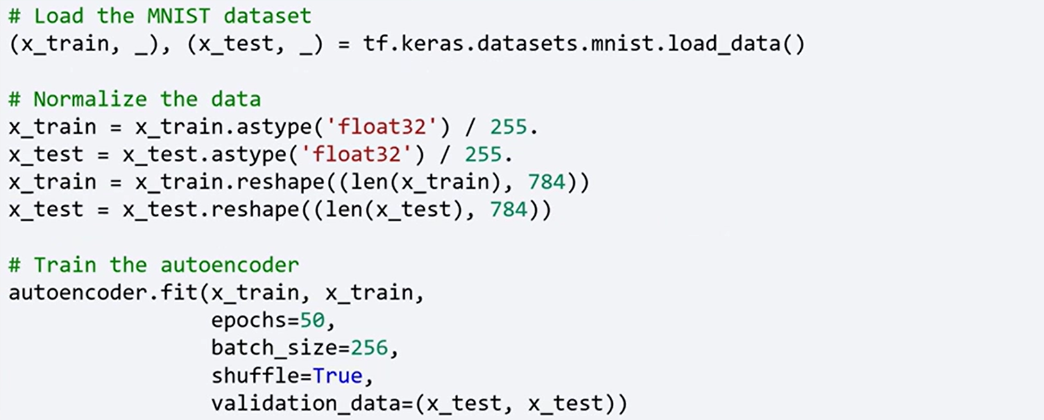

#### 🔍 Difference Between Autoencoders and Transformers

| **Feature** | **Autoencoders** | **Transformers** |
| --- | --- | --- |
| **Purpose** | Learn compact, efficient representations of input data for reconstruction, denoising, or compression. | Model dependencies across sequences for tasks like translation, classification, generation, or forecasting. |
| **Input/Output Structure** | Input and output are usually identical (or closely related); used for reconstructing the input. | Input and output may differ (e.g., source and target languages, time series to predictions). |
| **Architecture** | Composed of two parts: an encoder that compresses input into latent space and a decoder that reconstructs the original input. | Uses self-attention mechanisms in encoder-decoder or encoder-only stacks to process entire sequences. |
| **Attention Mechanism** | Typically absent (uses dense or convolutional layers); focuses on representation learning. | Central to the architecture; enables global context modeling across entire input. |
| **Use Cases** | Dimensionality reduction, anomaly detection, denoising, pretraining. | NLP (e.g., BERT, GPT), vision (ViT), time series forecasting, sequence-to-sequence tasks. |
| **Training Objective** | Minimize the difference between input and reconstruction. | Minimize prediction loss (e.g., cross-entropy, MSE) for output targets. |
| **Purpose** | Learn compact, efficient representations of input data for reconstruction, denoising, or compression. | Model dependencies across sequences for tasks like translation, classification, generation, or forecasting. |
| **Input/Output Structure** | Input and output are usually identical (or closely related); used for reconstructing the input. | Input and output may differ (e.g., source and target languages, time series to predictions). |
| **Architecture** | Composed of two parts: an encoder that compresses input into latent space and a decoder that reconstructs the original input. | Uses self-attention mechanisms in encoder-decoder or encoder-only stacks to process entire sequences. |
| **Attention Mechanism** | Typically absent (uses dense or convolutional layers); focuses on representation learning. | Central to the architecture; enables global context modeling across entire input. |
| **Use Cases** | Dimensionality reduction, anomaly detection, denoising, pretraining. | NLP (e.g., BERT, GPT), vision (ViT), time series forecasting, sequence-to-sequence tasks. |
| **Training Objective** | Minimize the difference between input and reconstruction. | Minimize prediction loss (e.g., cross-entropy, MSE) for output targets. |

### 🔹 Generative Adversarial Networks (GANs)

GANs are generative models introduced by **Ian Goodfellow in 2014**, consisting of two competing networks:

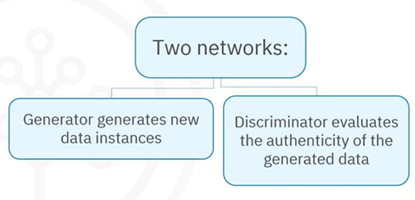**Generator**:

* Takes a random noise vector (e.g., 100 dimensions) as input.
* Produces synthetic data (e.g., a 784-dimensional image).

**Discriminator**:

* Receives real or generated data.
* Classifies input as either **real** or **fake**.

The **generator tries to fool the discriminator** while the discriminator tries to distinguish between real and fake data. This adversarial process leads to the generator producing increasingly realistic data.

**Simple implementation of GAN in Keras:**

In this code, simple GAN is defined, where the generator takes a 100-dimensional noise vector as input, and produces a 784-dimensional image.

The discriminator evaluates whether the image is real or generated.

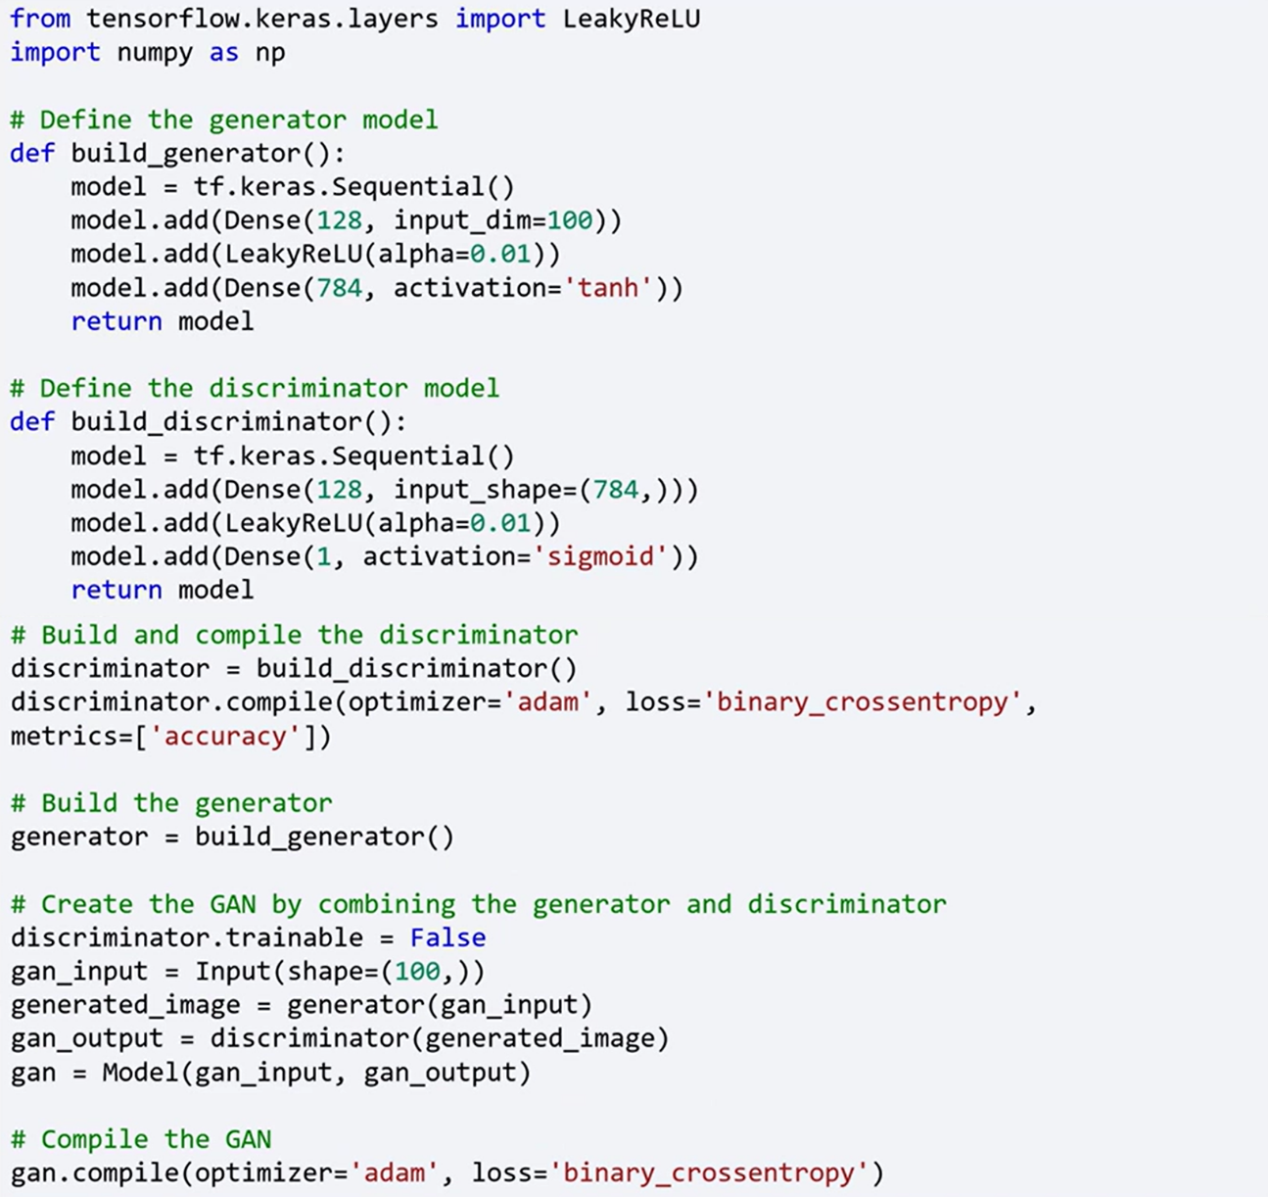



Training a GAN involves training the discriminator and generator alternately.

Here's a simplified version of the training loop.

This loop trains the discriminator to distinguish real images from generated ones and trains the generator to produce realistic images.

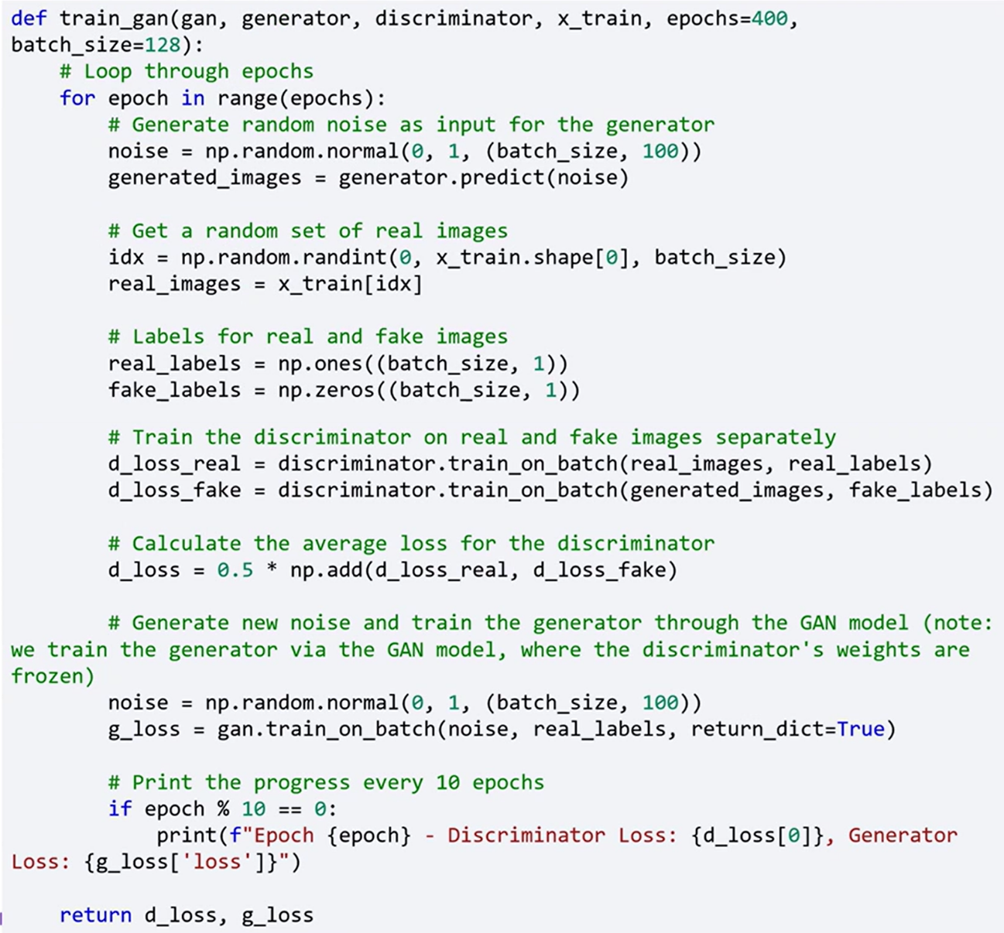

### ✅ Takeaways

✅ Unsupervised learning is used to discover patterns in data without labeled outputs or predefined targets.

✅ The three main categories of unsupervised learning are, **Clustering**, **Association**, **Dimensionality Reduction**.

✅ Autoencoders are neural networks that compress input data into a latent representation and then reconstruct it, learning efficient features in the process.

✅ Generative Adversarial Networks (GANs) consist of a generator that produces synthetic data and a discriminator that evaluates its authenticity. They are trained through adversarial competition to generate increasingly realistic outputs.

✅ Both autoencoders and GANs are powerful tools for representation learning and data generation, foundational in unsupervised deep learning with Keras.

.

## 📌 Building Autoencoders in Keras

Autoencoders are a specialized type of neural network used in **unsupervised learning**. They are commonly applied to tasks such as **dimensionality reduction**, **data denoising**, and **feature extraction**.

### 🔹 What is an Autoencoder?

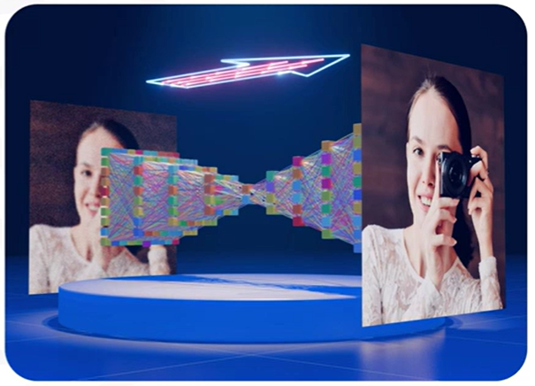

An **autoencoder** is a type of artificial neural network designed to learn **efficient representations** of input data, typically for the purpose of compressing and reconstructing the data.

It is composed of three main parts:

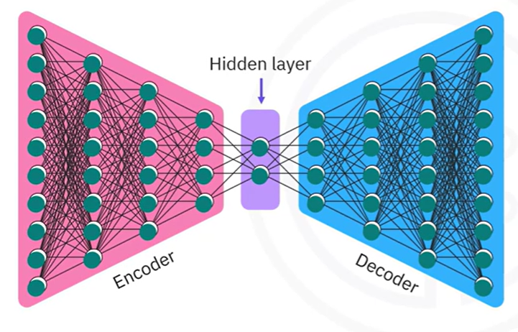**Encoder**:

Compresses the input data into a lower-dimensional latent representation.

**Bottleneck**:

The compressed intermediate representation where the most important features are preserved.

**Decoder**:

Reconstructs the original input from the compressed representation.

The autoencoder is trained by **minimizing the difference between the input and the reconstructed output**, forcing it to learn meaningful, compressed representations of the data

### 🔹 Type of Autoencoders

Autoencoders come in several forms, each adapted for different purposes:

**Basic Autoencoders**:

Feature a simple structure with one hidden layer in both the encoder and the decoder.

**Variational Autoencoders (VAEs)**:

Introduce probabilistic components and are designed for **generating new data samples**.

**Convolutional Autoencoders**:

Use **convolutional layers** and are especially effective for processing **image data**.

### 🔹 Building a Basic Autoencoder with Keras

The implementation is demonstrated using the **MNIST dataset**.

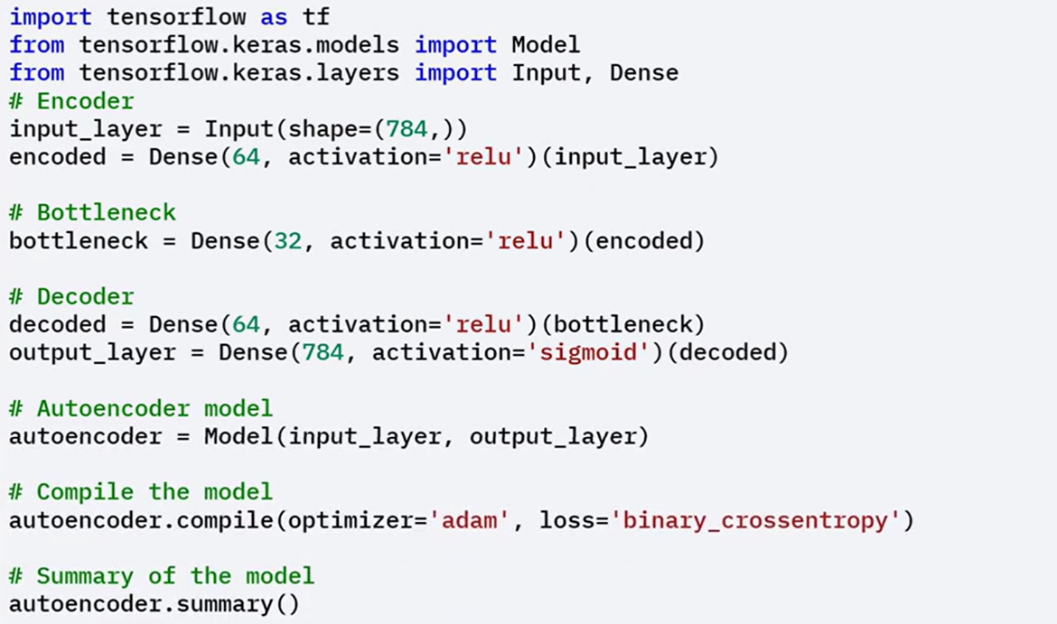**Structure**:

1. **Define the input layer**

With 784 neurons (28 × 28 image flattened).

1. **Construct the encoder**:

Reduce the dimensionality from 784 to 64.

1. **Create the bottleneck**:

Compress the 64-dimensional data further to 32 dimensions.

1. **Construct the decoder**:

Expand the data from 32 back to 784 dimensions to match the original input.

1. **Compile the model**.

**Data preparation and Training**:

1. **Load and preprocess the MNIST dataset**:
   * Normalize the pixel values.
   * Flatten the images into single 784-length vectors.
2. **Train the autoencoder**
   * Using the same dataset for both inputs and targets, teaches the model to **reconstruct the input data**.
   * Emphasizes learning internal data structure without needing labels.

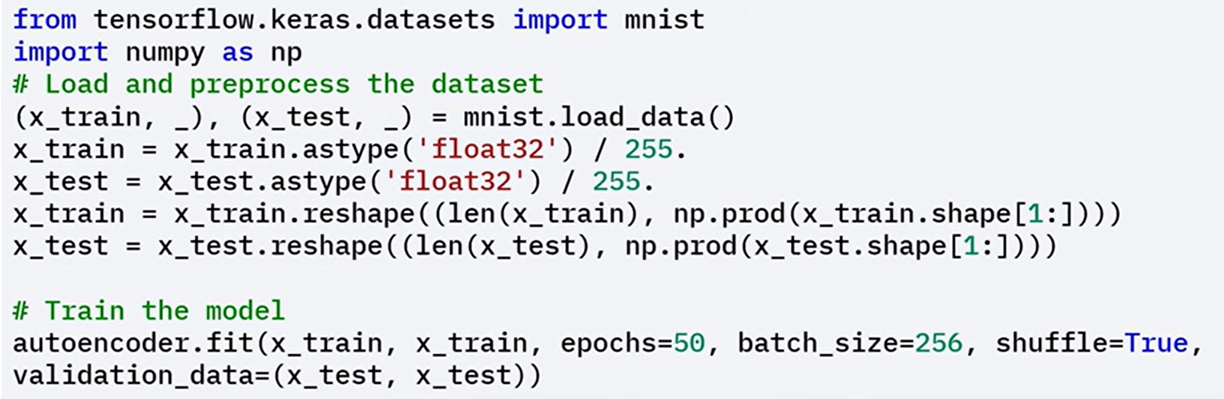

### 🔹 Fine-Tuning the Autoencoder

You can **fine-tune** a trained autoencoder by **unfreezing specific layers**, to allow parts of the network to be retrained on new or slightly different data.

This helps in adapting the autoencoder to new data or improving its performance

**Steps to Fine-Tune:**

1. **Unfreeze the last layers** of the autoencoder.
2. **Recompile the model** to update training configuration.
3. **Retrain the model** for a few additional epochs. This improves reconstruction accuracy or adapts the autoencoder to new input domains.

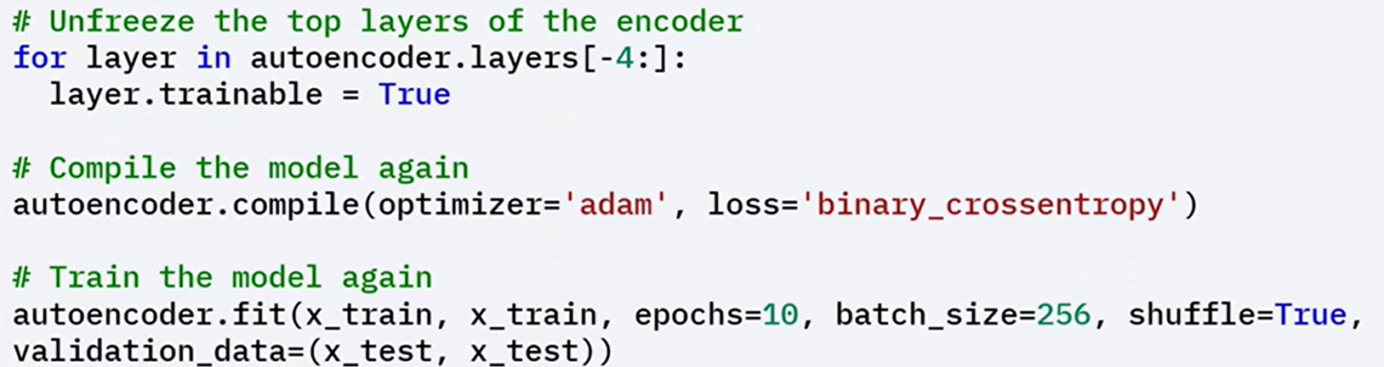

### 🧠 Key Concepts

Autoencoders work by compressing and reconstructing input data using an encoder–decoder structure.

They are trained by minimizing the reconstruction error between inputs and outputs.

The bottleneck forces the network to learn **core features** of the data.

Keras provides a flexible way to build and train these models using Functional API.

### ✅ Takeaways

✅ Autoencoders are effective tools for learning compressed representations of data in an unsupervised setting.

✅ The architecture includes an encoder, bottleneck, and decoder, which together compress and reconstruct input data.

✅ Keras makes it easy to implement and train autoencoders, and models can be fine-tuned to improve performance or adapt to new datasets.

✅ Different types of autoencoders serve specialized tasks, such as generation (VAEs) or image processing (convolutional autoencoders).

## 📌 Diffusion Models

Diffusion models are a type of generative model designed to create high-quality synthetic data.

These models have gained popularity due to their effectiveness in tasks such as image generation and enhancement.

### 🔹 What are diffusion models?

Diffusion models are **probabilistic neural networks** that generate data by **iteratively refining a noisy input**, such as random noise, until it becomes a coherent data sample.

Diffusion models generate data through a two-step:

* **Forward Process:** Adds noise to the original data over a series of time steps, converting structured input into random noise. The process mimics how data deteriorates gradually over time.
* **Reverse Process:** Trains the model to remove noise step by step, the model learns to recover the original sample by reversing the forward process, eventually transforming noise into a meaningful data instance.

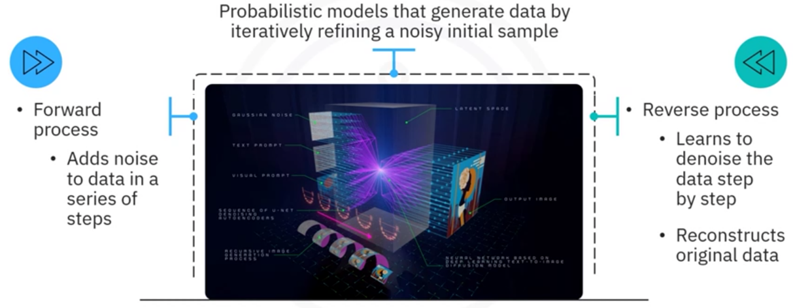

This approach mirrors the physical diffusion process, where particles move from areas of high concentration to low concentration. By learning how to reverse this noise process, the model can create new, coherent data from pure noise.

**Applications:**

**Image Generation**:

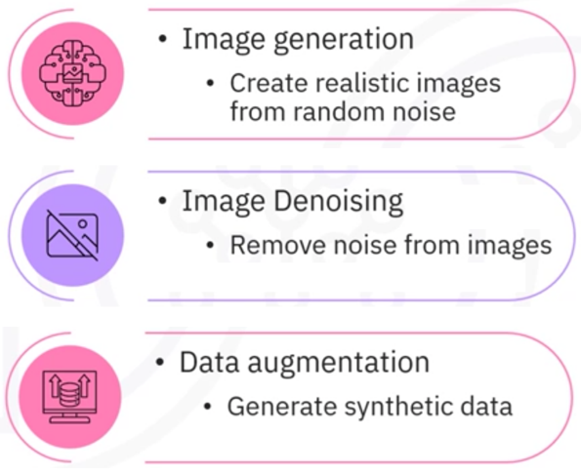They can generate realistic images, producing coherent visual content after the reverse denoising process.

**Image Denoising**:

These models can clean noisy images to restore original images.

**Data Augmentation**:

They can synthesize new samples that expand existing datasets, useful for training deep learning models in scenarios with limited labeled data.

### 🔹 Building a Diffusion model in Keras

The implementation uses the MNIST dataset and is designed to learn how to denoise images corrupted by random noise.

**1. Define model architecture**

* A simple **Convolutional Neural Network (CNN)** is defined as the diffusion model.
* The CNN takes a noisy 28x28 image as input.
* The image is processed through several convolutional and dense layers.
* The output is a denoised image of the same size as the input.

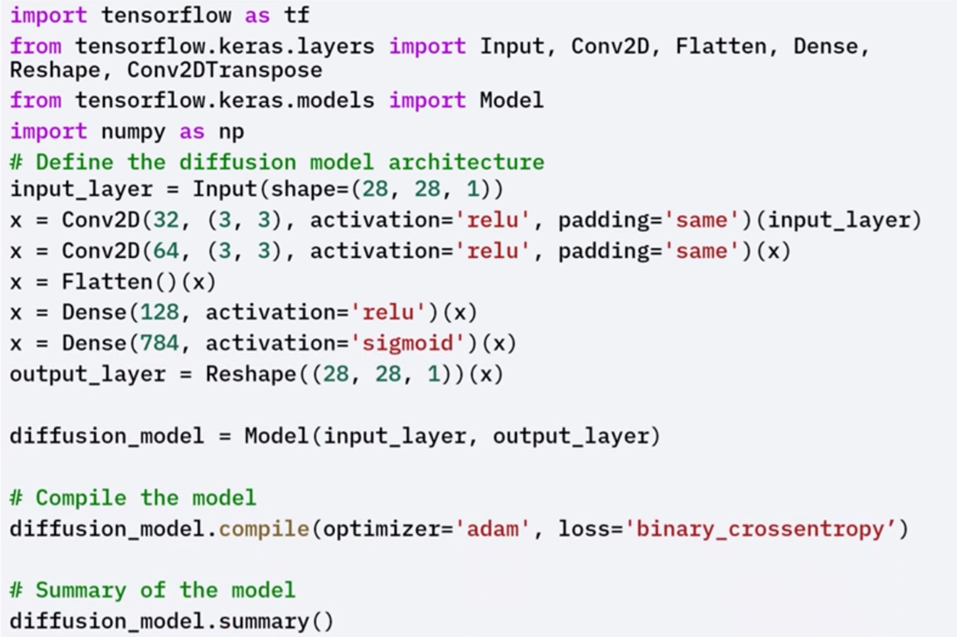

**2. Data Preparation**

* The **MNIST dataset** is loaded and preprocessed.
* Pixel values are normalized to the [0, 1] range.
* Random noise is added to the images to simulate the forward diffusion process.
* The noisy images are used as inputs, and the original images are used as targets for training.

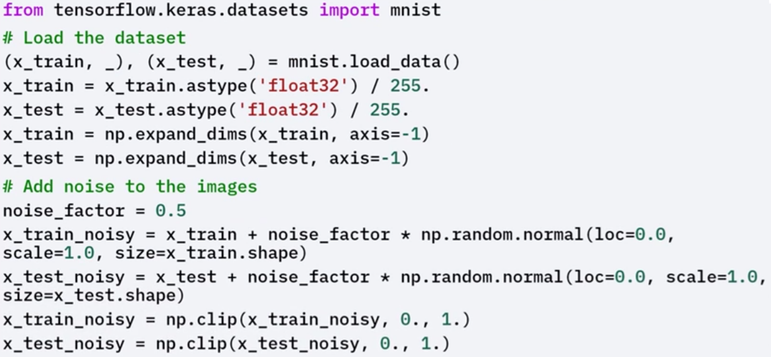

**3. Training and evaluating the Model**

* The model is trained on the noisy input images with the goal of reconstructing the original clean images.
* This trains the model to learn the reverse denoising process from noise to structure.

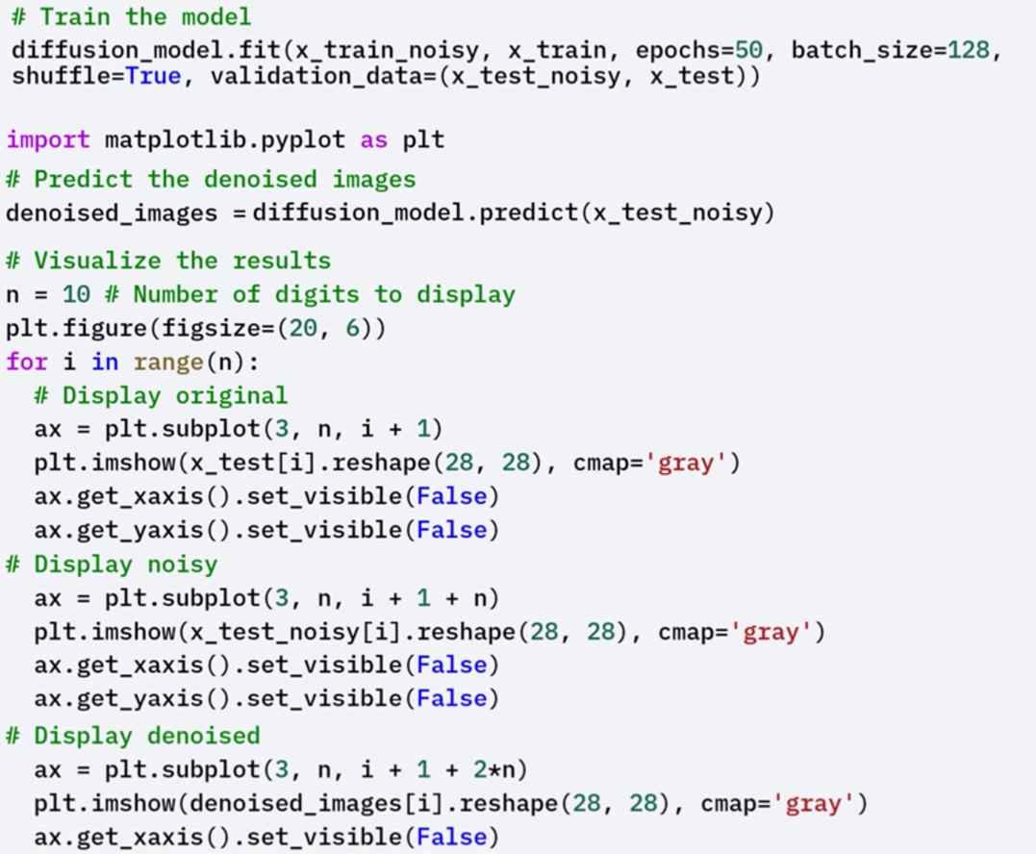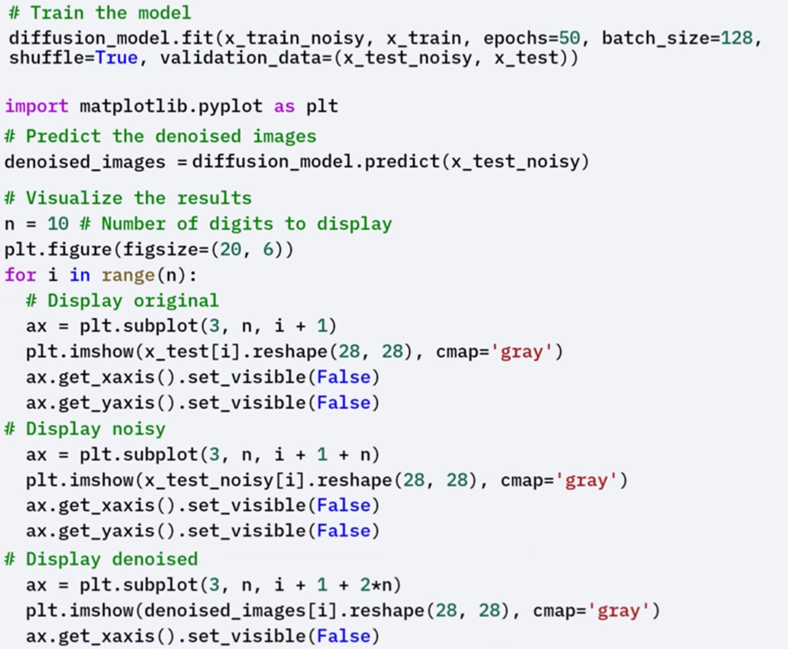

* After training, the model is evaluated based on its ability to restore images:
* The model makes predictions on noisy images.
* The predictions are visualized alongside the original and noisy images.
* This visual comparison demonstrates how effectively the model has learned to denoise inputs and reconstruct coherent outputs from corrupted data.

**🧪 Fine-Tuning**

To enhance performance, the model can be fine-tuned:

* The last four layers of the trained diffusion model are unfrozen.
* The model is recompiled and retrained for additional epochs.
* Fine-tuning helps refine the model’s parameters and can lead to improved denoising accuracy and better-quality image reconstruction.

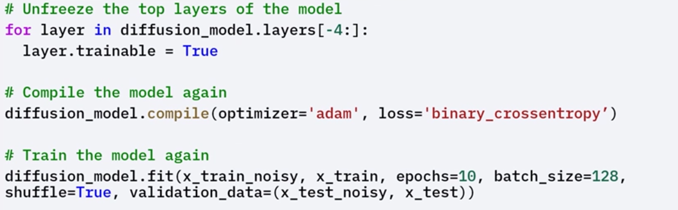

### ✅ Takeaways

✅ Diffusion models are generative models that work by progressively adding noise to data (forward process) and then learning to reverse this process to reconstruct original data (reverse process).

✅ They are inspired by the physical diffusion process and can generate data from pure noise through learned denoising.

✅ These models are widely used for image generation, denoising, and data augmentation.

✅ Using Keras, a diffusion model can be implemented with a CNN architecture, trained on noisy image inputs and clean targets, and further fine-tuned for improved results.